DataTraveler 70 USB Flash DriveUSB-C Flash Drive

Kingston’s DataTraveler 70® is a USB 3.2 Gen 1 compliant portable, lightweight USB-C1 flash drive. It’s designed to be used with compatible USB-C devices such as notebooks, laptops, tablets and phones. With capacities of up to 256GB2 , the DataTraveler 70 is more than capable of expanding your storage for everyday use. It comes backed with a 5-year warranty and free tech support.

* Designed for use with USB-C devices
* USB 3.2 Gen 1 compliant
* Portable and simple design
* 5-Year warranty and free tech support

Key Features



USB-C Storage

For use with USB-C devices like notebooks, tablets, and smartphones.

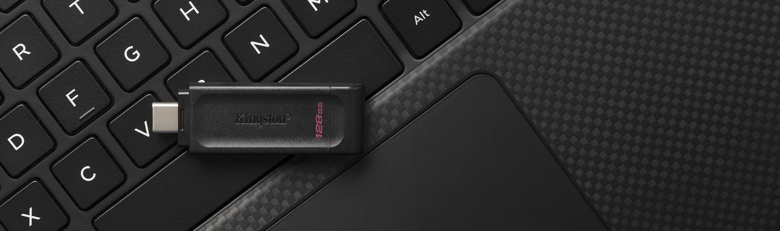

USB 3.2 Gen 1 compliant

Delivers up to 10X faster transfer speeds than USB 2.03.

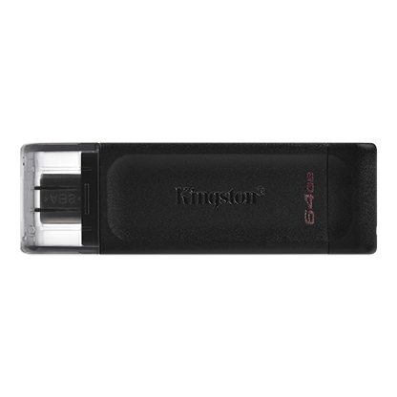

* [DataTraveler DT70 64GB](javascript:void(0))
* [DataTraveler DT70 64GB](javascript:void(0))
* [DataTraveler DT70 64GB](javascript:void(0))

Capacity

 64GB

 128GB

 256GB

* Part Number: DT70/64GB

[**Where to Buy**](https://www.kingston.com/en/wheretobuy)